ALEK SANDAR – BIOGRAPHY

“As a child, my biggest dream was to become a singer, to write my own music & share it with the world. It was something I could only fantasize about. I was seeing concerts on TV, watching video clips by those western singers and I was captured by all those movies playing in New York - the capital of the world, which was so terribly far away for me in post-communist-90's-Bulgaria.
Deep down in myself I am still the same child with the same dream and I am so f*cking thankful to be living this dream day by day. I have a long way to go and a lot more to share but on this day I am simply thankful for everything I have and for the fact that I can do what I love most - music!” Alek Sandar

Whether sitting in the 50 year old wing chair in his home in the Lower East Side, Manhattan, laying on the bare timber piling of his artsy pre-war apartment in former East Berlin, or looking out of the windows onto the bustling city in his place in central old Sofia, Alek Sandar draws inspiration from every facet of life. The Sofia-born Bulgarian is a true world citizen having lived in Cuba, Germany, Paris, New York and London.
“No single person has the right to classify people into groups or stereotypes. The soul has no color; it has no gender and no height. Neither has Music or the Arts, for love knows no language or boundaries (…) .” he says in an interview and the range of artists he collaborated with over the last years prove that.
The 26-year-old musician started playing the piano and singing in the Bulgarian National Group Radiodeca (Radiochildren) at the early age of 5 years. At the age of only 7, Alek Sandar composed his very first song, a ballad dedicated to his sister. In the same year, Alek has his very first appearance in the prestigious TV show Kato Luvovete (Like The Lions) in front of a national audience. In the mid 1990s, the severe economic crisis forces his family to leave Bulgaria in search for a better future.
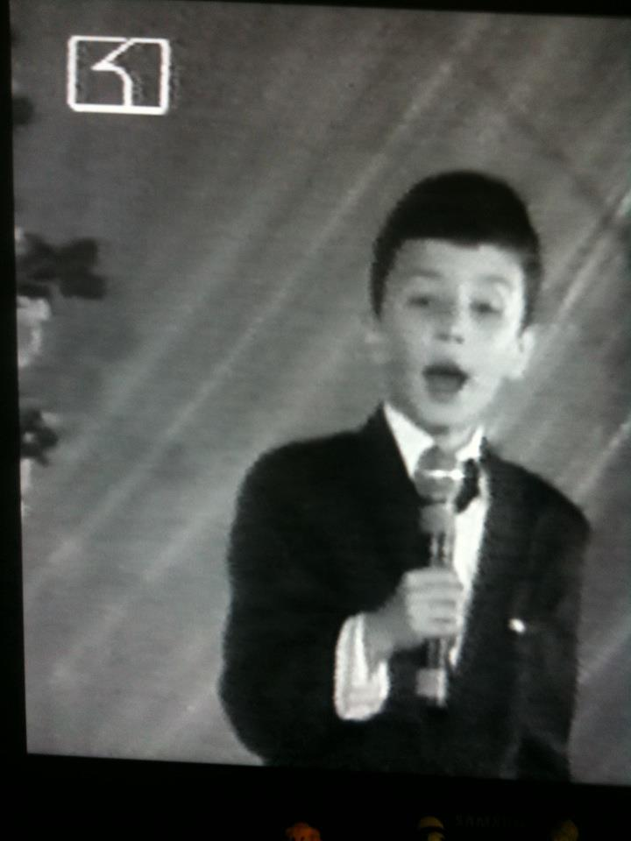
Alek Sandar spends his early teenage years in the peaceful German town Oldenburg, where he continues being on stage. Being the song of the opera singer Georgi Nikolov, Alek spends his surrounded by classical music, singing soprano arias in various German opera plays and festivals. During puberty, Alek takes acting classes for several years and experiences an extraordinarily dramatic first love, he discovers the highs and lows in life at an early stage. The developments in these early years of his life have a very strong impact on him identifying with numerous leading roles in productions of the German National Theater Staatstheater Oldenburg.
At the age of 17 Alek composes his first work to be released internationally: two melodic pop songs for the Serbian-Bulgarian Diva Reni. Encouraged by his first international success, Alek Sandar moves to Berlin in order to study “International Business Management” and to explore the world in search of gifted musicians and artist. Along with Jonathan Wuermeling, another young artist, they form the Electropop duo Splendid Sounds in 2008 and quickly become a performing nightife hit in the German metropolis.
Having breathed the air of the big city, Alek decides to relocate to the capital of the world – New York, where he instantly becomes an important part of the nightlife scene. In the years to follow, Alek lives in Paris, New York, London, Berlin and Sofia, collaborating with various international artists and music labels as a music producer, among them are French Star Academy celebrity Jérémy Amelin, Korean transcendental pop sensation Yozmit, Cherrytree-signed Frankmusik and the USA-Like-A-G6-idols Far East Movement, as well as an array of Bulgarian artists such as Andrea, Reni, Dess / Desislava and Kamelia. In 2012, Alek produces the debut album “Beast” for Oscar Loya who made global news after he represented Germany in the Eurovision Song Contest 2009. In 2013, Alek Sandar wins a remixing contest for Australian singer Kimbra’s Settle Down, leaving behind 120 other competitors from the rest of the world.
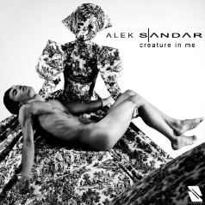
After years of work as composer and music producer, Aleksandar Nikolov decides to follow a career as a recording artist, giving birth to his artistic pseudonym Alek Sandar in 2012. A burning love affair changes his mindset and lifestyle and he clings onto a more spiritual world, taking a more self-assured approach to expressing his inner self with his audiovisual debut project Creature In Me, a song and video dedicated to the New Yorker nightlife scene. Alek delivers his debut as Creative Director in the official music video featuring famous New Yorker performers and Cirque Du Soleil artists, designs by Vivienne Westwood and Alexander McQueen.
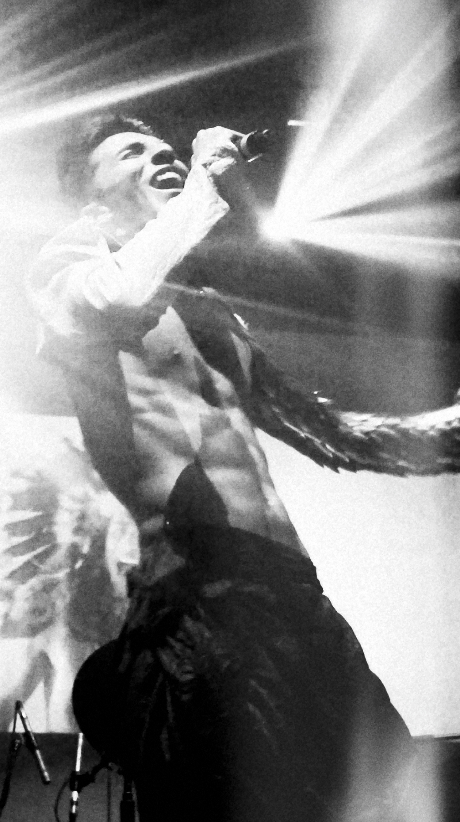
Only months after the release of Creature In Me, Alek Sandar headlines the prestigious New York Music Festival and New Music Seminar at Webster Hall in June 2012. The invitation comes from the founder of the festival Tom Silverman himself, who quotes that he has ‘never heard and seen anything of such production value that has not been released by a major label’. Alek Sandar is the first Bulgarian to have participated in this festival, which instantly gathers massive attention in national Bulgarian media and press.
In Fall 2012, Alek Sandar releases the electronic ballad I Adore You, a nostalgic yet modern-futuristic ballad creating a “bridge between the future and the past.”
The single is rapidly followed by a duet with one of the most acclaimed Bulgarian singers – DESS (also known as DesiSlava), considered one of the greatest Bulgarian voices of all times. The singers premiere It Ain’t Over with a video clip shot in Berlin. The single is a nationwide success and gets further airplay in many European countries, such as Germany, Poland and Russia.
In Manhattan, Alek Sandar is considered a nightlife celebrity, performing in some of New York’s most exciting locations: Vandam at Greenhouse, the Boom Boom Room at The Standard Hotel, Mansion, Tenjune, Webster Hall, Marquee, The Box, Sleep No More and the many fashion week after parties are just some to name.
In 2013, Alek Sandar tours around the world, singing, recording, producing and performing in New York, Berlin, Las Vegas, L.A., London, San Francisco and all over Bulgaria. In 2013, Alek is invited to be a special guest performer at the famous Vienna Life Ball and headlines the first DOMA Art Festival, a massive 2-week art Festival with national media coverage in Bulgaria.
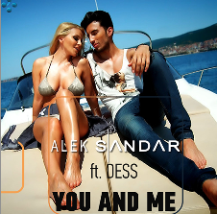
During summer 2013, Alek and Dess follow up with the summer hit “You and Me”, an instant success in Bulgaria and other Eastern European countries. The single is released on all digital stores worldwide with a remix bundle including progressive house, deep house remixes and a Bulgarian version. Alek also produces another Bulgarian summer hit: Dess’ dance track Baby.
Alek’s long anticipated debut EP “Meteors” comes out on January 31st 2014. It has been produced in New York, Berlin and Sofia in cooperation with the American producer group Boyplay. Next to the singles with Dess, it features the duet “Peaceful Place” with the hottest Balkan export act Andrea and the autobiographic song “Meteors”. The pilot “Say That You Love Me” is released on the global music video platform VEVO, making Alek Sandar the first Bulgarian artist with a channel on that video streaming platform. In the video clip, Alek proves again his talent as director and producer, shooting at world famous locations such as the Plaza Hotel in Manhattan, thus demonstrating that music is an audiovisual medium for him. The song is also presented to a wide audience in Germany at the concert Classic Meets Pop in Oldenburg, one of the yearly musical highlights of Northwest Germany, following airplay on a high number of German radio stations.
With “Peaceful Place” the artists start a campaign in support of minorities around the world deprived of Human Rights, supporting victims in Ukraine, Russia, Venezuela and Syria. International media, including CNN report about this. In an interview, Alek says that both artists would have been arrested, if they had released this song with the same video in Russia. The video clip shows Alek and Andrea holding up the rainbow flag / LGBT flag in a slum neighborhood in Sofia, surrounded by Roma and other ethnic minorities of al ages. The singers premiere the song with a live performance at the yearly Planeta TV awards, one of Buglaria’s music highlights of the year.
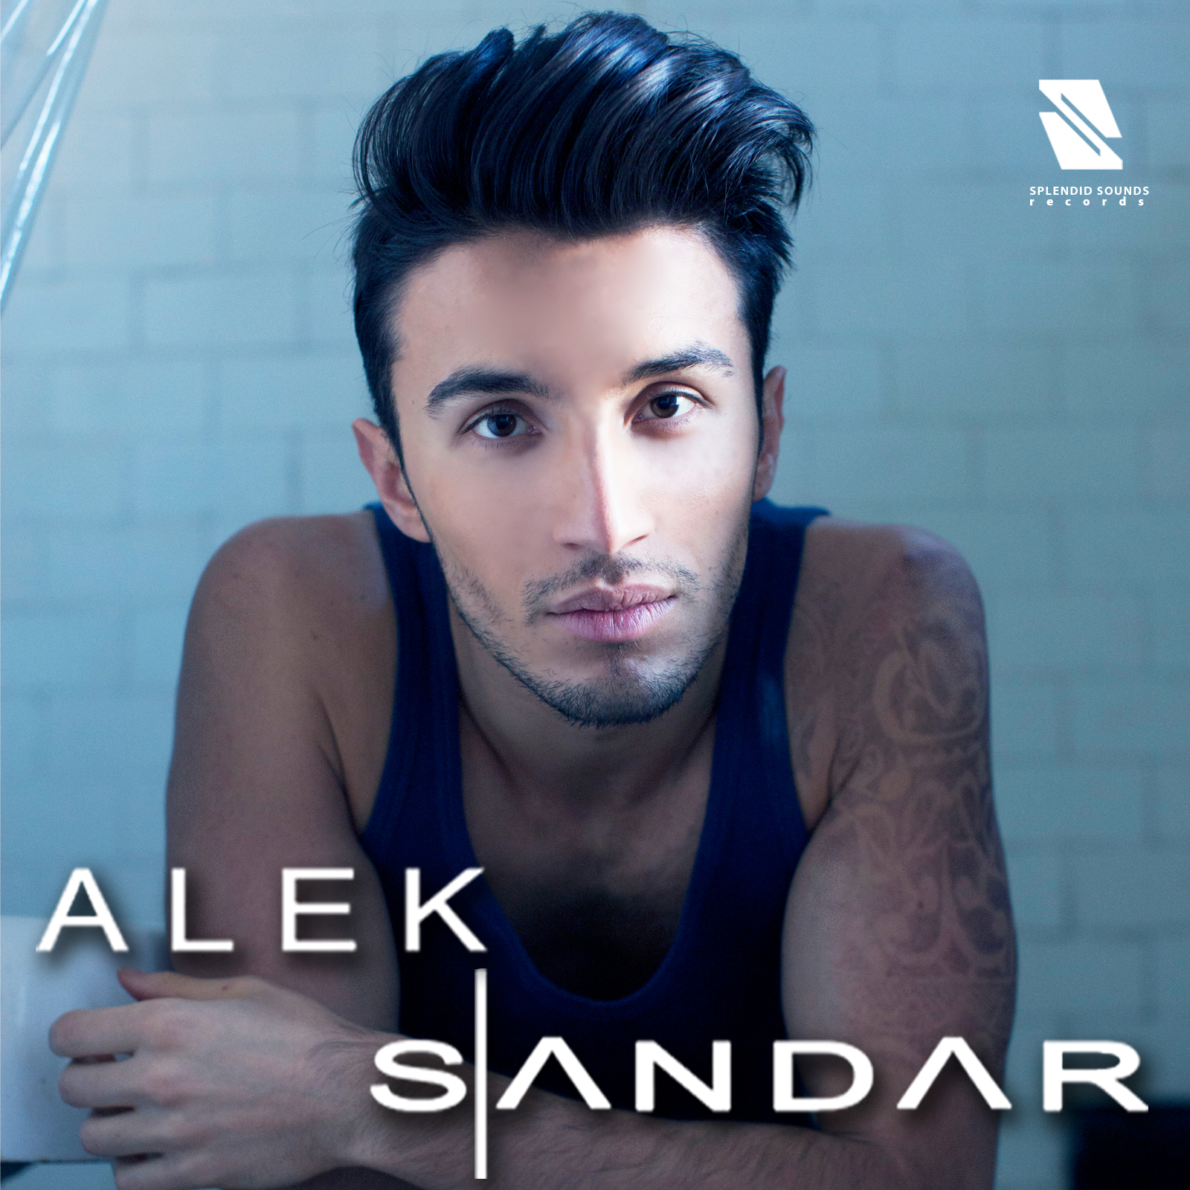

Meteors available on January 31st

More information on Alek Sandar:,
Homepage | Facebook | Instagram | Wikipedia | Video Clips | Performances | TV Interviews

Links
Creature In Me: http://www.youtube.com/watch?v=Y3z-wmu4Ksk
I Adore You: http://www.youtube.com/watch?v=zB0kbjI3waM
Premiere “It Ain’t Over” (with Dess): http://www.youtube.com/watch?v=M5DC-JqJsck
“It Ain’t Over” (with Dess) : http://www.youtube.com/watch?v=aXlJlgRgfuw
“You and Me” (with Dess): http://www.youtube.com/watch?v=jBTPPSTcGpg
“Say That You Love Me” http://www.youtube.com/watch?v=Q2cxny7HjCU
More information on Alek Sandar:,
Homepage | Facebook | Instagram | Wikipedia | Video Clips | Performances | TV Interviews

Please direct your requests for the USA to:
management@splendidsoundsrecords.com

Please direct your requests for Europe and the rest of the world to:
jonathan@splendidsoundsrecords.com

For more information, pictures, videos, news and contact details, please go to:

www.alek-sandar.com
www.splendidsoundsrecords.com
www.facebook.com/splendidsounds
www.facebook.com/aleksandarofficial

###

© 2014 Splendid Sounds Records

